**Web Server Down:**

**Follow the following procedure when you receive calls regarding a Web Server being down. You also receive a text message along with the call which consists of the last two octets of the IP address.**

1. VPN to the network.
2. Open your browser, enter the IP address of the web server in question as seen below.

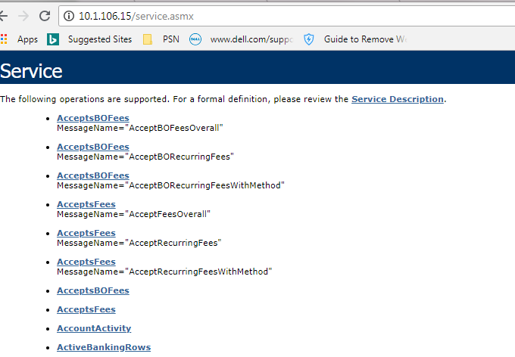

1. If the server is down, then you should get error messages.